Tables: 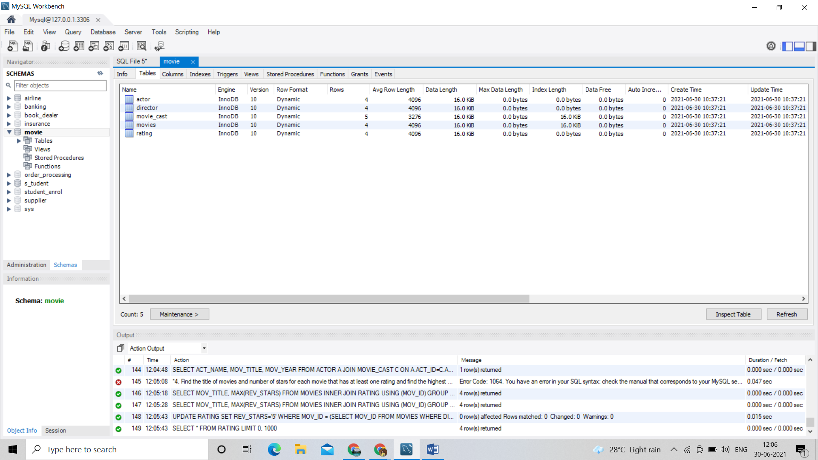

Columns:

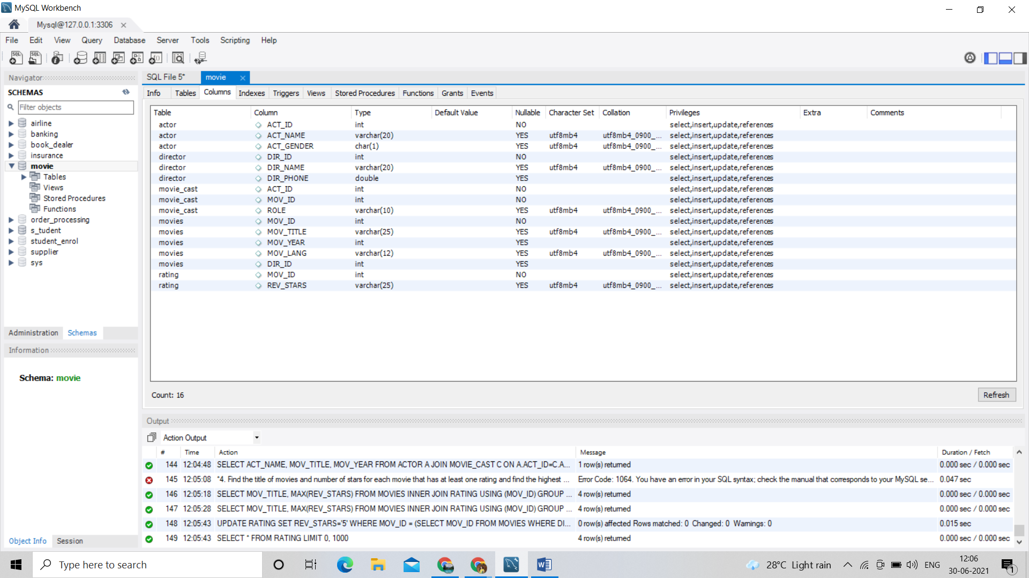

Result 1:

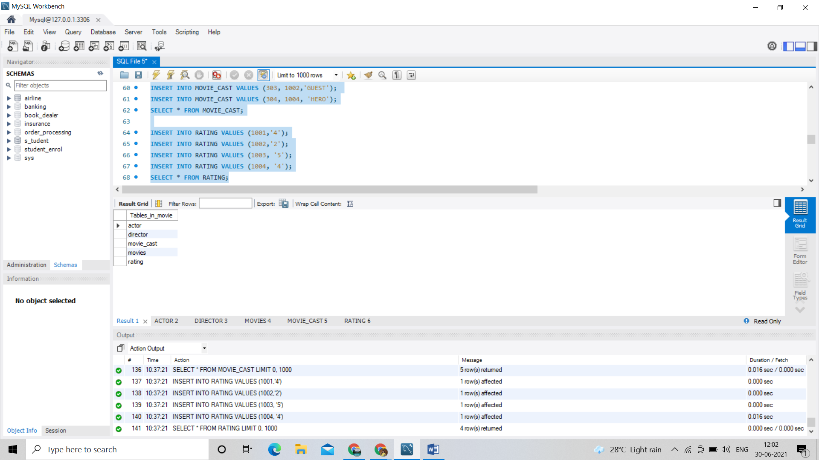

Actor 2:

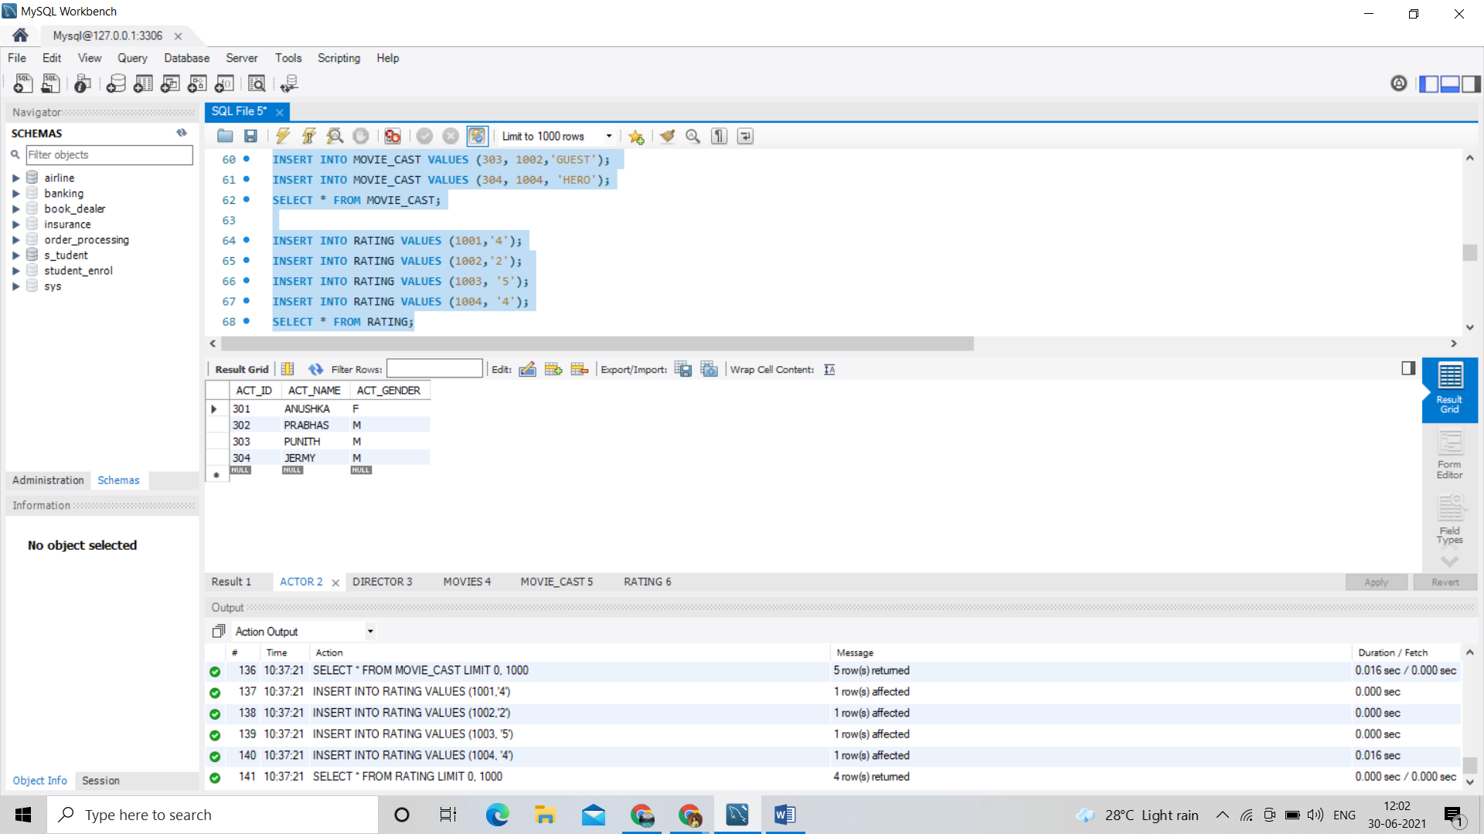

Director 3:

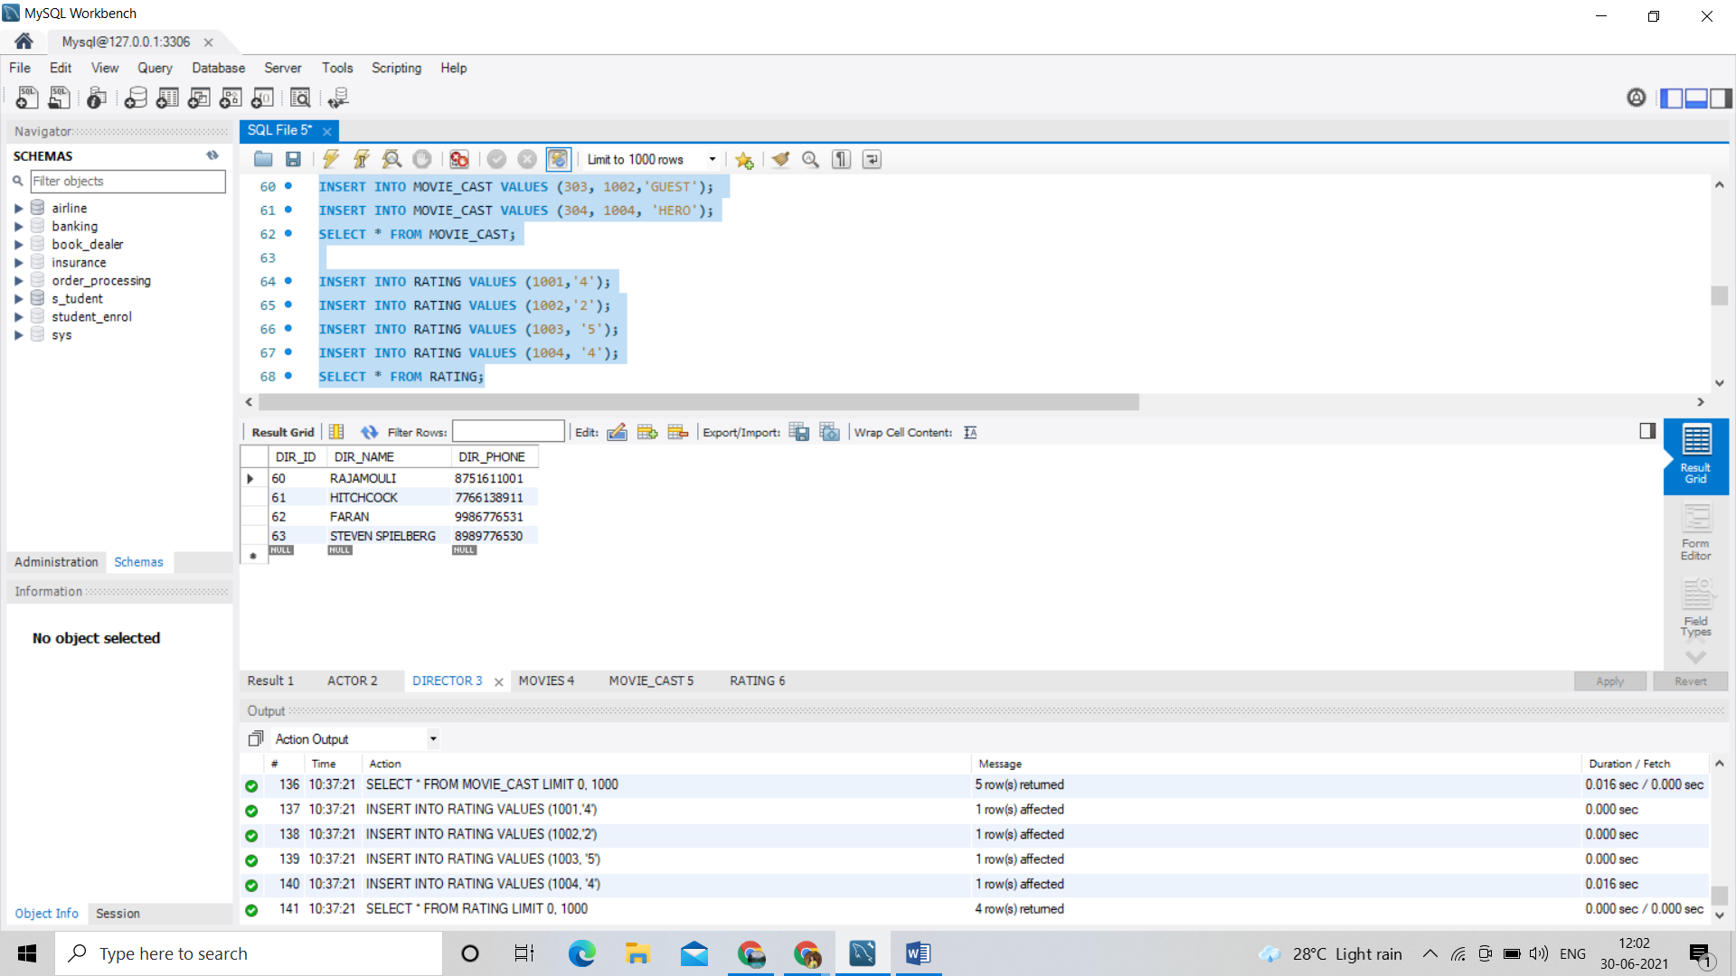

Movies 4:

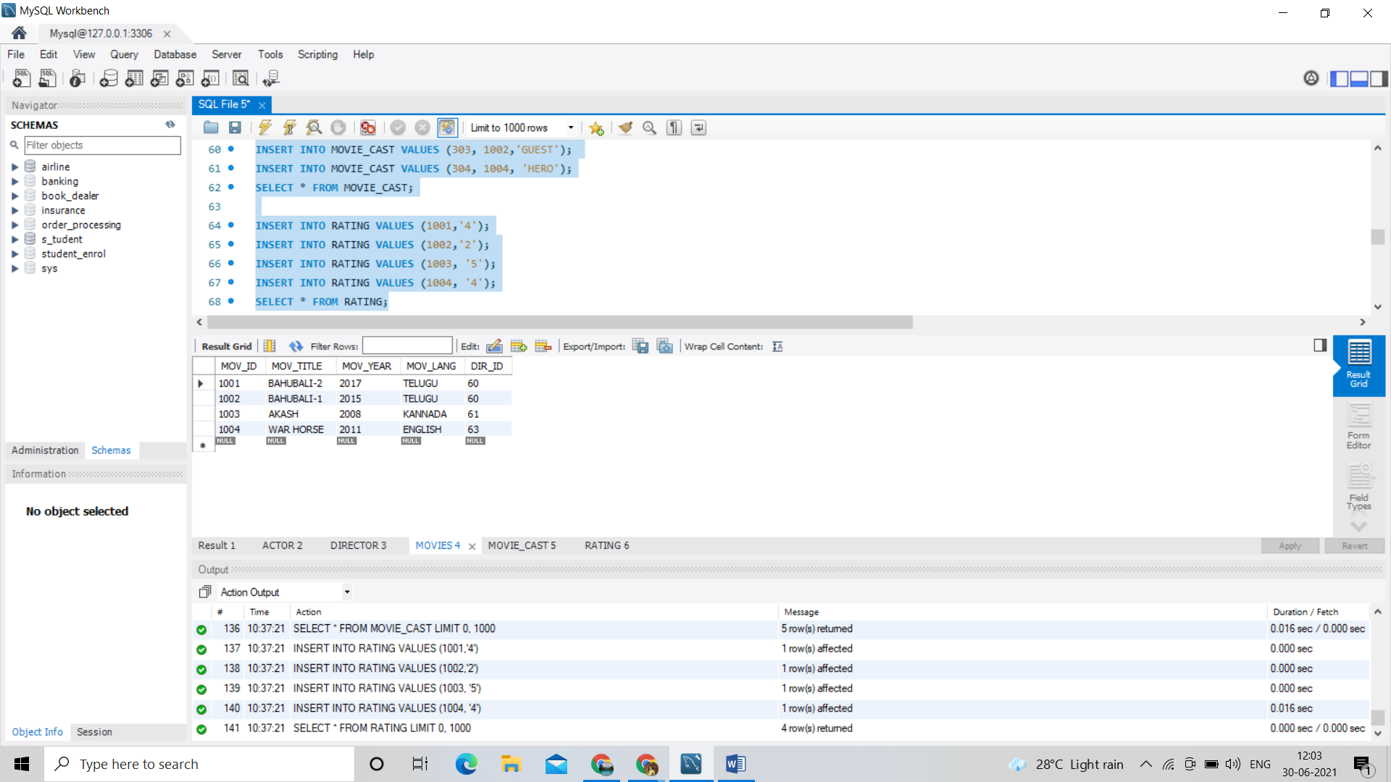

Movie_cast 5:

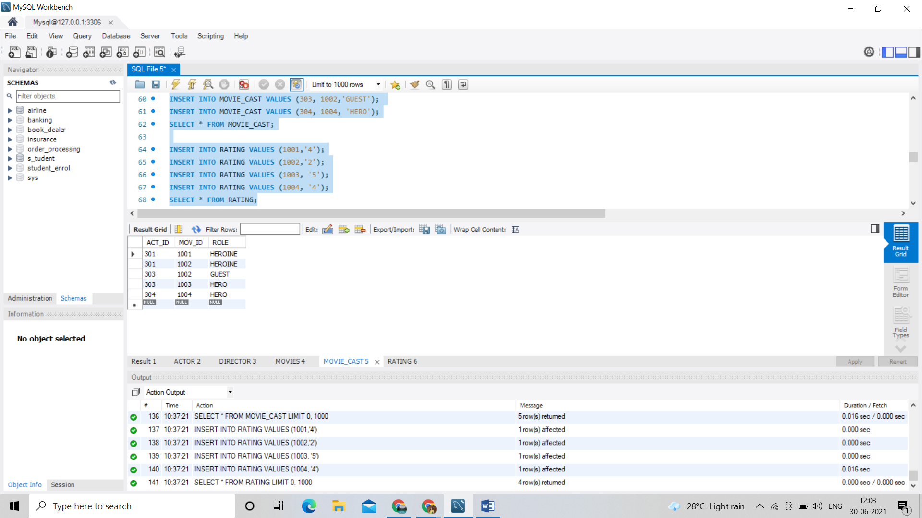

Rating 6:

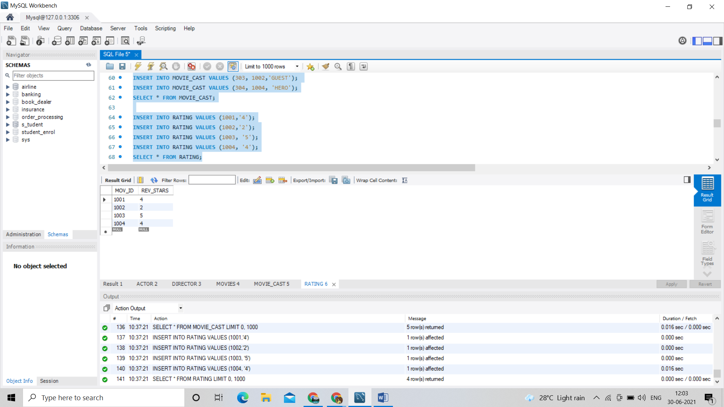

/*1. List the titles of all movies directed by‘Hitchcock’.*/

SELECT MOV_TITLE

FROM MOVIES

WHERE DIR_ID IN (SELECT DIR_ID

FROM DIRECTOR

WHERE DIR_NAME = 'HITCHCOCK');

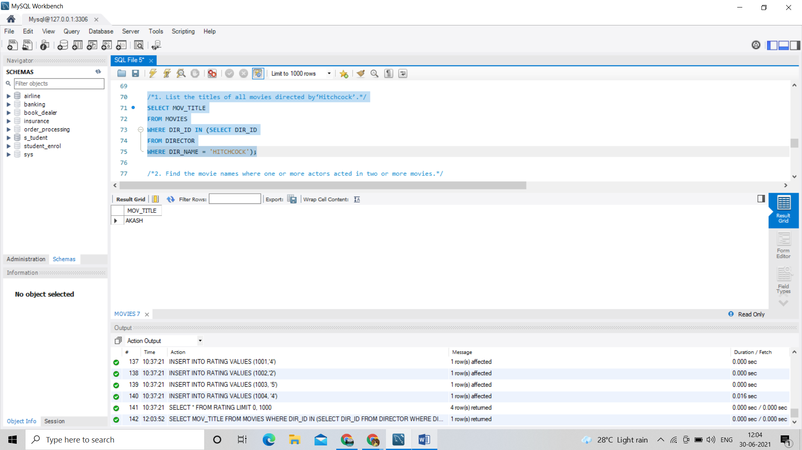

/*2. Find the movie names where one or more actors acted in two or more movies.*/

SELECT MOV_TITLE

FROM MOVIES M, MOVIE_CAST MV

WHERE M.MOV_ID=MV.MOV_ID AND ACT_ID IN (SELECT ACT_ID

FROM MOVIE_CAST GROUP BY ACT_ID HAVING

COUNT(ACT_ID)>1)

GROUP BY MOV_TITLE HAVING COUNT(MOV_TITLE)>1;

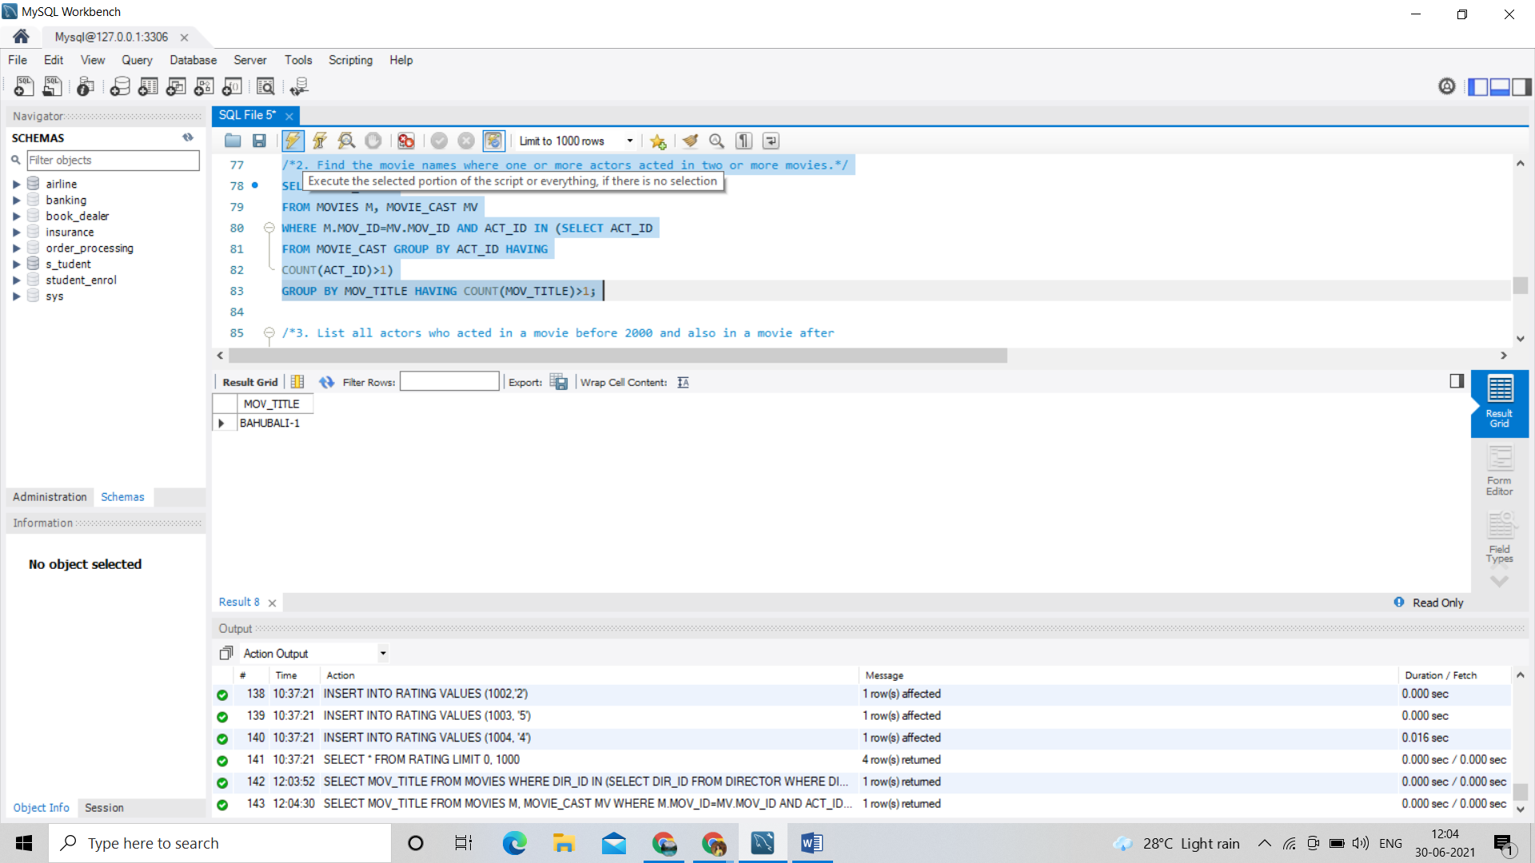

/*3. List all actors who acted in a movie before 2000 and also in a movie after

2015 (use JOIN operation).*/

SELECT ACT_NAME, MOV_TITLE, MOV_YEAR

FROM ACTOR A JOIN

MOVIE_CAST C

ON A.ACT_ID=C.ACT_ID

JOIN MOVIES M

ON C.MOV_ID=M.MOV_ID

WHERE M.MOV_YEAR NOT BETWEEN 2000 AND 2015; 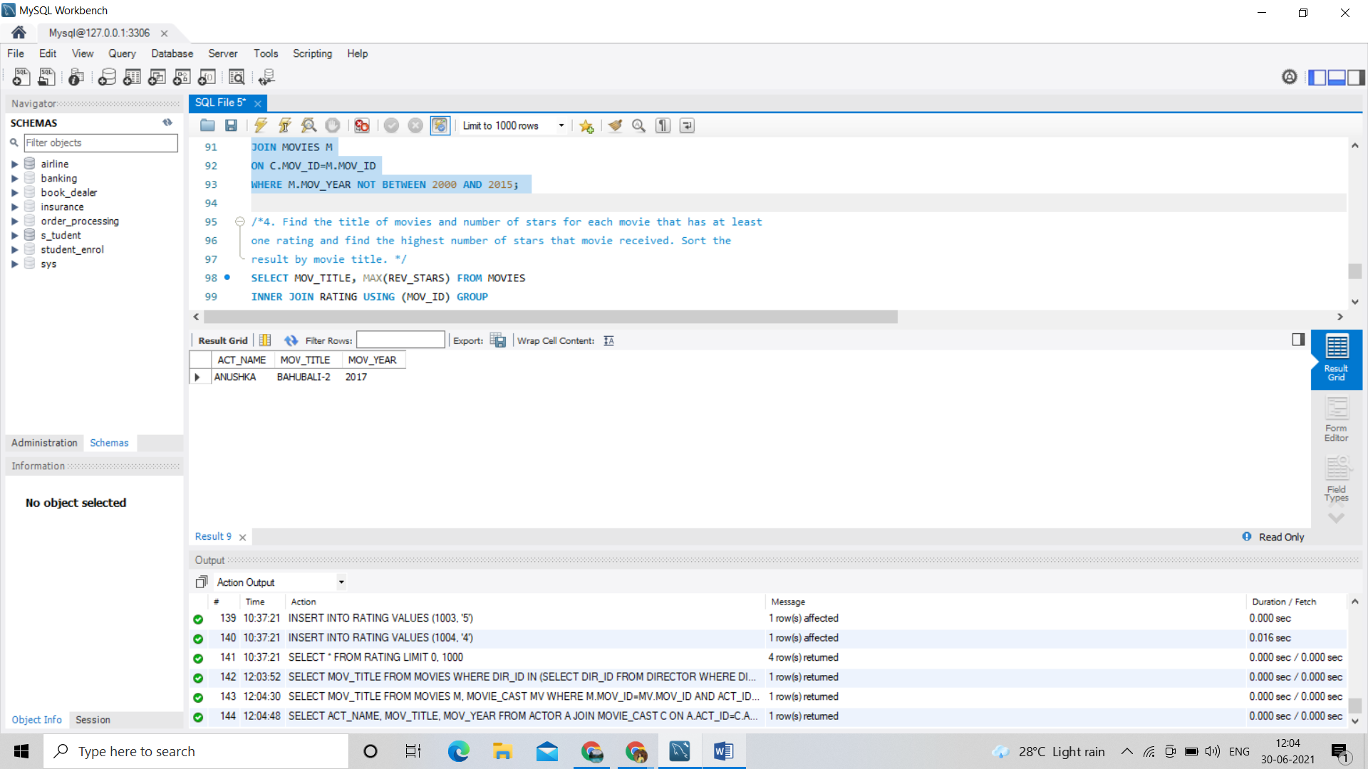

/*4. Find the title of movies and number of stars for each movie that has at least

one rating and find the highest number of stars that movie received. Sort the

result by movie title. */

SELECT MOV_TITLE, MAX(REV_STARS) FROM MOVIES

INNER JOIN RATING USING (MOV_ID) GROUP

BY MOV_TITLE

HAVING MAX(REV_STARS)>0

ORDER BY MOV_TITLE; 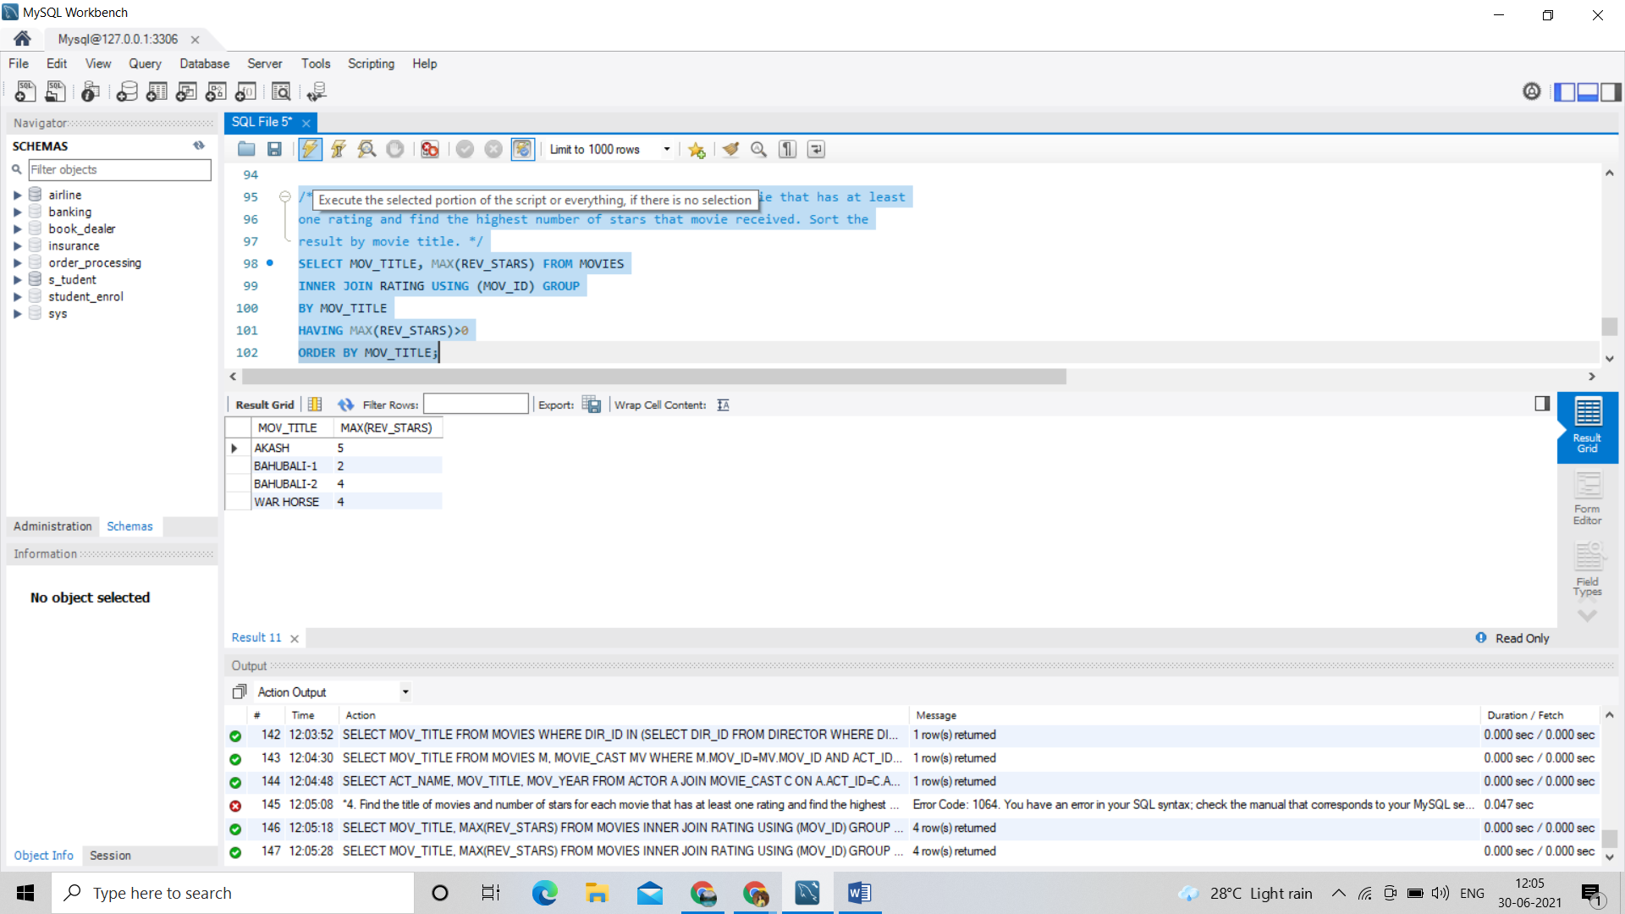

/*5. Update rating of all movies directed by ‘Steven Spielberg’ to 5*/

UPDATE RATING

SET REV_STARS='5'

WHERE MOV_ID = (SELECT MOV_ID FROM MOVIES

WHERE DIR_ID = (SELECT DIR_ID FROM DIRECTOR

WHERE DIR_NAME ='STEVEN

SPIELBERG'));

SELECT * FROM RATING; 